College of Medicine
Cash Management Process

Purpose

The purpose of the cash management process is to transfer funds biweekly from departmental FCPA funds to corresponding PeopleSoft cost centers (funds 171 and 910 Source of Funds HSCFCPA) to cover payroll and non salary expenditures paid out of PeopleSoft. The process normally begins the Monday after Friday payday. A listing of cash balances is distributed to the cashmng email contacts to use in determining funding needs. The departmental contacts provide a request for funding by Tuesday at noon to Shirley F Williams. Once the review process is complete, a final report is distributed to the cashmng email contacts for verification of transfer amounts.

The goal for our college is to maintain a healthy cash balance in our practice plan, Florida Clinical Practice Association (FCPA), so departments should only transfer funds as needed on a biweekly basis.

PeopleSoft funds 171 and 910 HSCFCPA are cash based. There is no budget checking for encumbrances, only for expenditures. You do not need to transfer funds in order to set up a Purchase Order. You should transfer funds when you are ready to process the payment to the vendor.

The Dean’s Office must actually cut a check from the FCPA and deposit the check into UF PeopleSoft in order to move the funds as requested via the cash management process.

Financial Reporting

The College of Medicine Cash Management process is like transferring money from your savings account to your checking account. The process does not create additional money – it is just a transfer of existing funds. Therefore, the Cash Management process does not affect the actual bottom line of the department.

The funds involved in cash management (FCPA, 171 and 910 HSCFCPA) are all considered ‘unrestricted’ by the College of Medicine (a term used in our financial reporting). The transfer out of FCPA is offset with a transfer into 171 or 910 HSCFCA, so there is no net impact on the Budget to Actual College of Medicine Financial Reports. The following account codes are used for the transfers:

FCPA Acct Code 9230 (transfer out) → PS Fund 171 HSCFCPA Acct Code 430000(transfer in)
FCPA Acct Code 9210 (transfer out) → PS Fund 910 HSCFCPA Acct Code 430000 (transfer in)

Cash Management Activity on Financial Statements

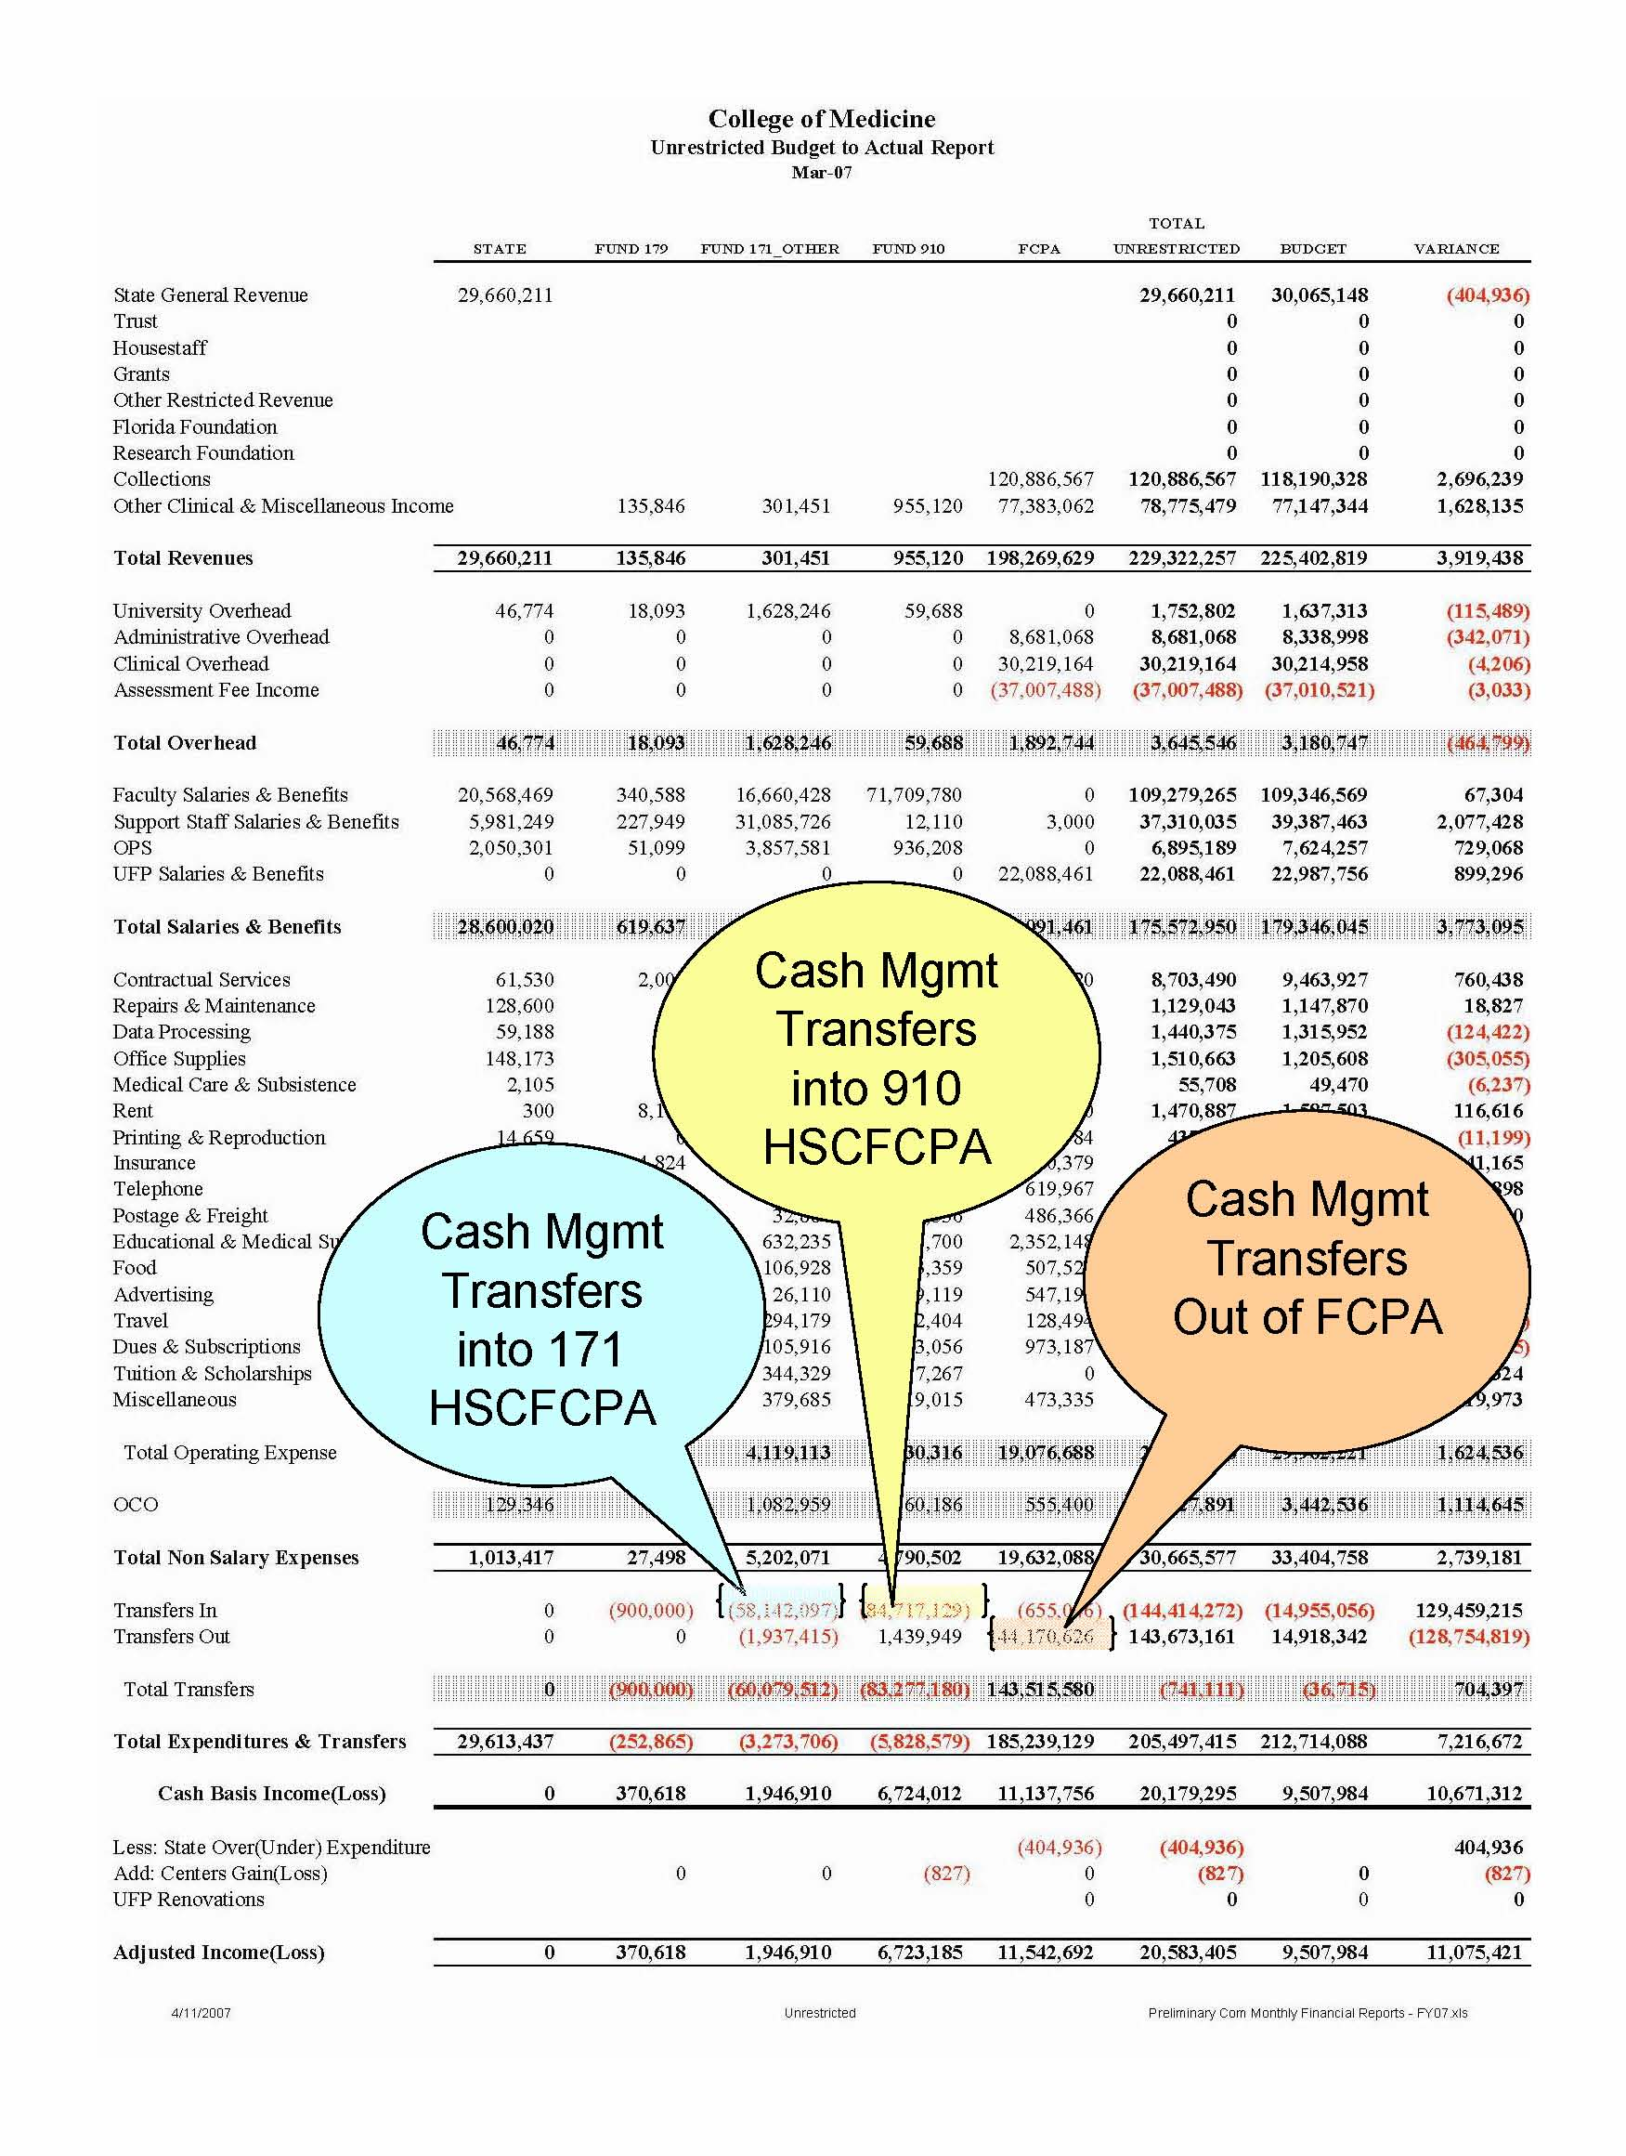

Although it is not a preferred situation, if a department transfers more funds than needed to 171 or 910 HSCFCPA, it will not impact the financial results.

There are several methods that can be used to correct an over funding situation. The department can leave the balance in their fund 171 or 910 HSCFCPA cost center and request no (or less) funding from the next cash management cycle. The department can move funds between their divisional deptids with a UF GL Journal (and a FCPA Journal to adjust as needed). Or the department can contact Shirley F Williams to request assistance if they cannot adjust within departmental cost centers.

Other Considerations

It is important for departments to review all of their fund balances and understand their current year budget.

General Revenue (State) is considered ‘unrestricted’ for College of Medicine Financial Reporting. The college’s General Revenue is monitored by Nancy Smith (will be transitioned to Kathy Thrasher). You should not make any changes to distributions on General Revenue (funds 101 and 102) without consulting Nancy Smith (or Kathy Thrasher). The budget allocations you see in PeopleSoft have no correlation to the amounts reported on the College of Medicine Budget to Actual Financial Statements.

You should not use ‘unrestricted’ funds for items you have budgeted to use ‘restricted’ funds (UFF, UFRF and grant funding). Be sure to consult Beverly Anders or Kathy Peck if you need assistance.

